MUTHUKUMAR .R

NETWORK ENGINEER
📍 Chennai, Tamil Nadu, India | 📞 +91 9080415583|
🔗linkedin.com/in/muthukumar-r-a8b58388

✉ muthukumarravindhran@gmail.com

Certified Network Engineer (CCNA) with 7+ years of experience in ISP, telecom, and network operations environments. Skilled in routing & switching, DSLAM operations, WAN troubleshooting, and NOC monitoring across multi-vendor platforms including Cisco, Huawei, Ericsson, and ZTE. Proven ability to resolve network incidents within SLA, optimize network performance, and support enterprise connectivity solutions.

WORK EXPERIENCE

Network Support Engineer
Tata Communications–Chennai, Mar 2022 – May 2026
Monitor and maintain LAN, WAN, and MPLS infrastructure using SolarWinds and Nagios in a 24×7 NOC environment.
Troubleshoot Layer 1–3 network issues including link failures, router/switch outages, and latency problems.
Configure and support Cisco networking devices including routing protocols such as BGP and OSPF.
Experienced in configuring and managing Cisco 1900 Series Integrated Services Router and Cisco Catalyst 3560 Switch / Cisco Catalyst 3750 Switch switches for enterprise network environments. Perform incident management, root cause analysis (RCA), and escalation handling following SLA guidelines.
Perform VLAN creation, deletion, and configuration for enterprise customers.
Support network services including VPN, DNS, DHCP, and enterprise connectivity solutions.
Coordinate with ISPs and field engineers for outage resolution and service restoration.
Participate in network migration and upgrade projects, ensuring minimal service impact.
Conduct proactive network monitoring to identify bottlenecks and optimize bandwidth usage.
Document incidents, changes, and network configurations following ITIL processes.

NOC Engineer
Airtel Networks Pvt Ltd – Chennai Oct 2017 - Mar 2022
Configured and managed DSLAM platforms (Alcatel, Huawei, Ericsson, ZTE) for broadband service deployment.
Monitored network performance using NETCOOL, MRTG, Huawei U2000, and ZTE U31.
Troubleshot WAN connectivity issues, VLAN allocation, and network outages.
Managed FTTH networks, Ruckus access points, BRAS connectivity, and AAA authentication servers.

EDUCATION
BE Electronics & Communication Engg 2012 - 2015
Sri Shakthi Institute of Engineering and Technology
Coimbatore.

TECHNICAL SKILLS
Networking & Security Palo Alto (Firewall) TCP/IP, OSI Model
IP Addressing & Subnetting ARP, DNS, DHCP
SD-WAN
AWS

Routing & Switching
VLAN & Trunking(802.1Q) STP Concepts
Static Routing OSPF, BGP (Basic)
MPLS Fundamentals

Network Operations
Incident& ChangeManagement SLA Monitoring
Root Cause Analysis (RCA)
Bandwidth Upgrade &LinkMigration

Monitoring & Tracking Tools
BMC Remedy / ITSM SolarWind Nagios
NETCOOL MRTG
Huawei U2000 ZTE U31
Wireshark ICRM

COURSE COMPLETED

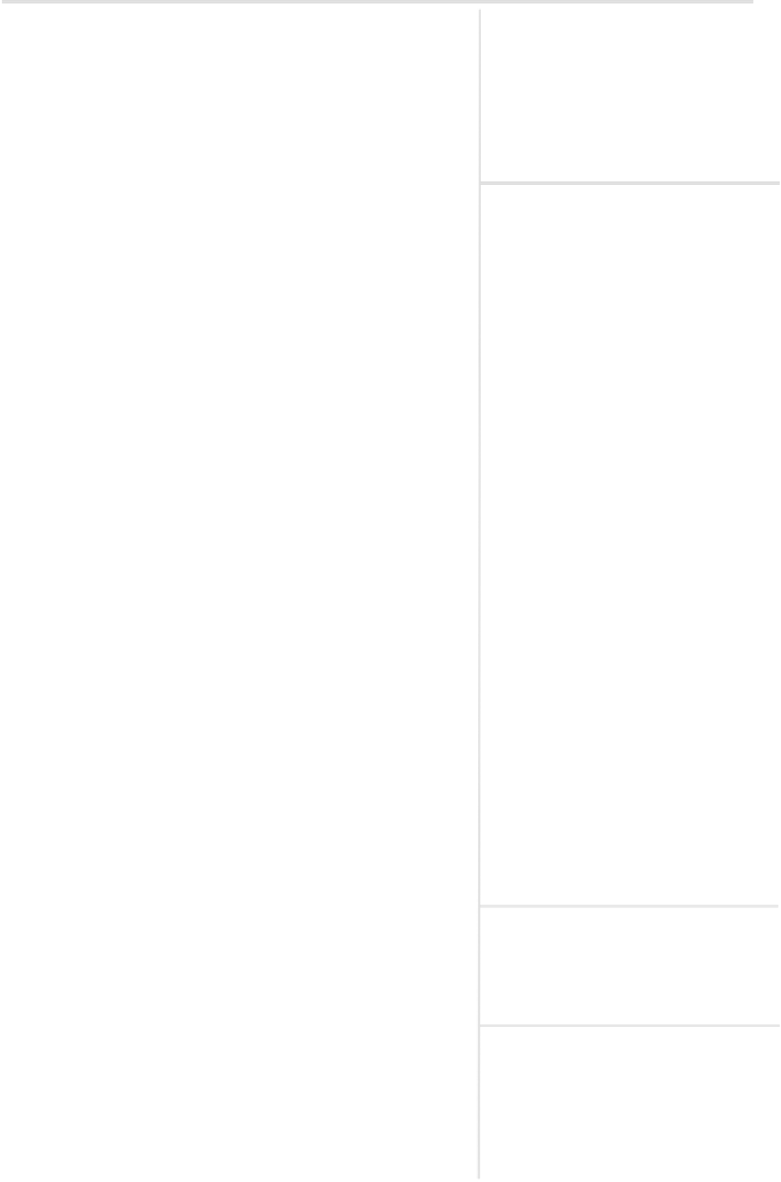
Conducted packet analysis using Wireshark to diagnose recurring network issues.
Migrated customers from legacy Alcatel/Ericsson DSLAMs to Huawei platforms.
Documented network topology diagrams, SOPs, and operational procedures.
Collaborated with vendors and internal teams to perform software upgrades and network enhancements.
Assisted in training new engineers and improving incident response time by 20%.
CCNA (Cisco Certified Associate) - 2026

LANGUAGES
English – Fluent Tamil – Fluent Telugu – Speaking
Network

